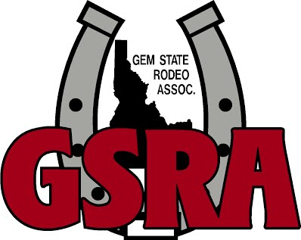
Rodeo #2 Information

Date: Sunday June 12, 2022
Start Time: 9am with the dummy roping outside, followed by grand entry and calf riding.
Location: Badiola Arena, 402 US-95, Homedale, Idaho
Stalls: Stalls are available for $10/night. You may use any of the galvanized stalls that are open, covered or by the road. Please contact Tricia Seal for stall reservations, info and payment. 208-816-0833
Day Sheets: There will be a limited number of day sheets for sale at the rodeo for $1.00, located at the dummy roping.
Concessions: Concessions will be provided by Badiola Arena/Moxie Java. Please don’t bring outside food and drink in the indoor arena area.
Volunteers: Our entire association is run by volunteers. Parents, please make sure your kids are ready to go when it’s their turn and help out when you can. If you’re not sure what to do, please contact a Board Member or Event Director and let them know you’re willing to help, or just jump in and help if you see a need at the rodeo. We try to make things go as quickly and smoothly as possible. Also, please be respectful of the facility, pick up after yourself and your kids.
Rules: Please familiarize yourself with all the rules prior to your event. It is your responsibility to know the rules and have all your own help in the events where help is required (hazers & pushers). We require full western attire, cowboy hat, western boots, jeans and a button down, long sleeve shirt. You must wear a cowboy hat through the gate, or you will receive a no time. Parents, if your child loses their hat, please run in the arena and get it. If your kid’s horse runs around the arena, or back to the gate, please help catch them and get them out of the arena.

